Program Information | [Lesson Title]  Frogs at Risk |  |  |  |  |  | TEACHER NAME  Billie Walters |  |  |  | PROGRAM NAME  Mid-East Career & Technology Centers
Program Information | [Unit Title]  Environment and Ecology |  |  |  |  |  | NRS EFL(s)  3 |  |  |  | TIME FRAME  120 – 180 minutes
Instruction | OBR ABE/ASE Standards – English Language Arts and Literacy
Instruction | Reading (R) |  | Writing (W) |  |  | Speaking & Listening (S) |  |  |  | Language (L)
Instruction | Foundational Skills |  | Text Types and Purposes |  |  | Comprehension and Collaboration |  |  |  | Conventions of Standard English
Instruction | Key Ideas and Details | R.3.3  R.3.4  R.3.7 | Production and Distribution of Writing |  |  | Presentation of Knowledge and Ideas |  |  |  | Knowledge of Language
Instruction | Craft and Structure |  | Research to Build and Present Knowledge | W.3.6 |  |  |  |  |  | Vocabulary Acquisition and Use
Instruction | Integration of Knowledge and Ideas | R.3.16
Instruction | LEARNER OUTCOME(S)  - Students will be able to explain scientific text explicitly when drawing inferences; support points with evidence, and write an essay based on research about problems facing amphibian populations and their possible causes. |  |  |  | ASSESSMENT TOOLS/METHODS  - Class discussion  - Making Inferences Chart  - I Know…I Wonder… T-chart  - Research Essay
Instruction | LEARNER PRIOR KNOWLEDGE  - Close reading of The Frog Scientist should be completed before beginning this lesson. Teacher Note The Frog Scientist is a trade book, obtain a set from your local library for your students.  - Students will have completed Text Structure and Organization prior to reading this book; a sequence graphic organizer is provided in this lesson as reinforcement to finding text structures.  - Students have conducted research and written essays prior to this lesson.
Instruction | INSTRUCTIONAL ACTIVITIES  - Students have read The Frog Scientist and have an understanding of what the author is explaining about the risk of atrazine (pesticide) on the frog population. Provide students with the article Frogs at Risk and read aloud or students can read independently or as a group.  Guide class discussion with these questions about Frogs at Risk.  Q.1 According to the text, what is the risk for many species of frogs and toads in Ecuador (find on map)?  Q.2 What are three possible causes of this risk given by scientists?  Continue the discussion, referring back to The Frog Scientist.  Q.3 What was Tyrone Hayes trying to find out with his experiment on the frogs from Dugway Pond?  Q.4 What do Tyrone and his team want to learn?  Q.5 Write one sentence that explains what Tyrone and his team are doing at Dugway Pond and what they want to learn.  Q.6 What are the two main reasons why Tyrone Hayes want to know how atrazine affects frogs?  Q.7 Explain how pesticides end up in ponds, streams, and rivers.  Q.8 Why did Tyrone collect some frog eggs from Dugway Pond before he put atrazine into the pond?  Refer to both texts to answer these questions.  Q.9 How might Tyrone’s experiment help other scientist understand what is happening to amphibian populations in North and South America?  Q.10 How might Tyrone’s work save amphibians?  - Several of these questions lead students to making inferences about what they know and what clues they found in the text. Inferences are evidence-based guesses. They are the conclusions (synonymous term) a reader draws about the unsaid based on what is actually said. Inferences drawn while reading are much like inferences drawn in everyday life. If your best friend comes in from a blind date and looks utterly miserable, you would probably infer the date was not a success. Drawing inferences while you read requires exactly the same willingness to look at the evidence and come to a conclusion that has not been expressed in words. Only in reading, the evidence for your inference consists solely of words rather than actual events, expressions, or gestures.  To pull meaning from the page, readers need to draw all kinds of inferences. They need to infer main ideas; figure out how sentences and paragraphs relate; connect supporting details to main ideas; match pronouns to antecedents; understand the function of allusions; and determine how visual aids contribute to the author's message (this is just a partial list). While it's commonly assumed that writers supply every word readers need to construct meaning, nothing could be further from the truth. Readers almost always help create the texts they read. Those readers who don't draw inferences to fill in gaps in the text are likely to miss or misunderstand the meaning intended by the author.  - Provide the Making Inferences Chart and Atrazine Turning Frog Princes Into Frog Princesses? article students begin analyzing details and their own knowledge to make inferences.  - First, choose a significant detail. To understand the author’s perspective, find a detail that seems to show the author’s feelings or belief. Write it in the chart in column one.  - For column two, identify what you know that can help you make an inference. Now review details and background knowledge to make an inference. State your inference in the chart. Teacher and students continue these steps, adding inferences to the chart, using the same passage.  - Students can continue making inferences using the Making Inferences Chart and A Field of Nightmares? Atrazine, Corn, and Frogs article Students can also gain additional practice making inference by using classroom resources or completing websites such as Making Inferences I.  This lesson is based on a report by the Land Stewardship Project and Pesticide Action Network North America January 2010. To gain more information about pesticides and their effects, students might want to read The Syngenta Corporation & Atrazine: The Cost to the Land, People, and Democracy.  - This scientific research has prompted students to have many questions about the environmental effects of pesticides on plants, animals and even humans. An effective strategy to gather all their questions is the I Know…I Wonder Research T-chart (attached).  - Students can begin to list the information they want to know about the topic (pesticides and frogs) under “What I Know.”  - For each point, think of a few questions you would like to answer. List the questions under “What I Wonder.”  - Consider all your questions and write a one-sentence answer to “What do I want to find out about my topic?”  - Using one of your questions, research using multiple sources from books, articles and videos. Write a short essay to share your investigation of this topic with the class. Remember to provide evidence from the text to support your analysis and research. |  |  |  |  |  |  | RESOURCES  Turner, P. S., & Comins, A. (2011). The Frog Scientist (Scientists on the Field Series). Boston, MA: HMH Books for Young Readers.  Projector, ability to project  Student copies of Frogs at Risk article (attached)  ReadWorks.org | Frogs at Risk. (n.d.). Retrieved from http://www.readworks.org/passages/frogs-risk-0  Student copies of Making Inferences Chart (attached)  Student copies of Atrazine Turning Frog Princes Into Frog Princesses? article (attached)  Frogs Are Green. (n.d.). Retrieved from http://frogsaregreen.org/atrazine-turning-frog-princes-into-frog-princesses/  Student copies of A Field of Nightmares? Atrazine, Corn, and Frogs article (attached)  A Field of Nightmares? Atrazine, Corn, and Frogs. (n.d.). Retrieved from http://frogsaregreen.org/a-field-of-nightmares-atrazine-corn-and-frogs/  Frog Scientist: Dr. Tyrone Hayes and Atrazine. (n.d.). Retrieved from http://frogsaregreen.org/frog-scientist-dr-tyrone-hayes-and-atrazine/  Making Inferences I [PDF file]. (n.d.). Retrieved from http://www.ereadingworksheets.com/reading-worksheets/making-inferences-cleaner.pdf  (Optional resource) The Syngenta Corporation & Atrazine: The Cost to the Land, People, and Democracy [PDF file]. (n.d.). Retrieved from http://civileats.com/wp-content/uploads/2010/02/AtrazineReportJan2010.pdf  I Know…I Wonder Research T-chart (attached)  Resources for research  Our Stolen Future: Atrazine disrupts frog development. (n.d.). Retrieved from http://www.ourstolenfuture.org/NewScience/wildlife/frogs/20020416hayesetal.htm  Sanders, R. (n.d.). Pesticide atrazine can turn male frogs into females. Retrieved from http://news.berkeley.edu/2010/03/01/frogs/  Early-life exposure of frogs to herbicide increases mortality from fungal disease. (n.d.). Retrieved from http://phys.org/news/2013-10-early-life-exposure-frogs-herbicide-mortality.html  NATURE | Frogs: The Thin Green Line | Chemical Runoff | P... (n.d.). Retrieved from https://www.youtube.com/watch?v=nBbkwlGM7X0  Frogs And Pesticides. (n.d.). Retrieved from https://www.youtube.com/watch?v=UPT6YZBK8gI  FULL STORY: Pesticide Peril? (n.d.). Retrieved from https://www.youtube.com/watch?v=S1wsIMYlc-w
DIFFERENTIATION

- Use of graphic organizers support drawing inferences and conducting research, giving students tools that are applicable to future reading and research activities.
- Students work individually and in groups, while the teacher models use of the skills and concepts presented in this lesson.
- Resources are presented using multi-modalities, allowing for the various ways students learn best.
- Guided discussion gives students thought-provoking questions to encourage understanding of texts.

Reflection | TEACHER REFLECTION/LESSON EVALUATION
Reflection | ADDITIONAL INFORMATION

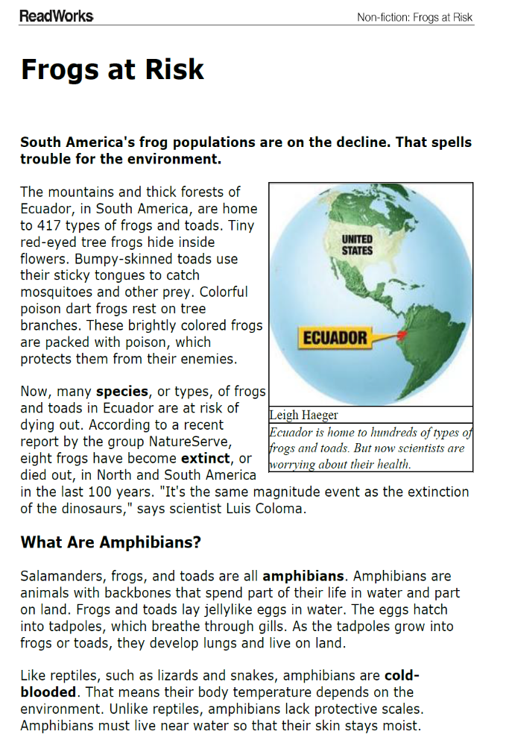
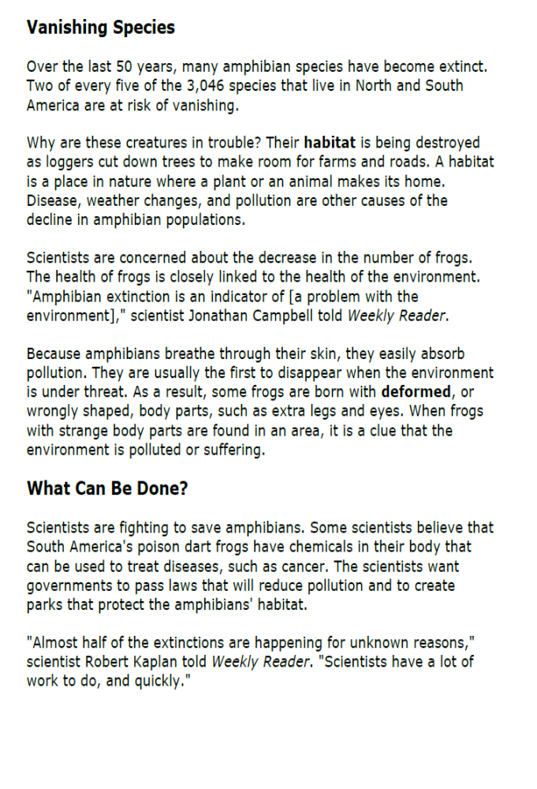
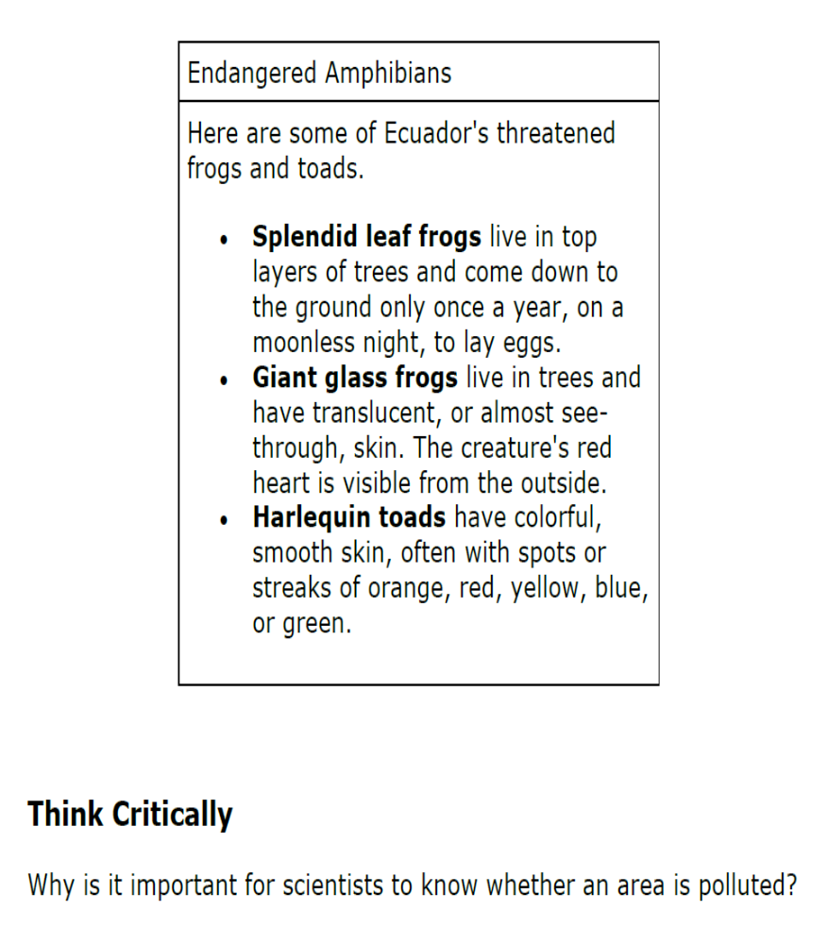

Making Inferences Chart
Inference = What You Know + Clues from the Text

Detail or Clue | What I Already Know | Inference

Frogs are Green Blogs

Atrazine Turning Frog Princes into Frog Princesses?
Posted on March 25, 2010 by Susan
Last summer, we wrote a post, Rachel Carson’s Legacy, about troubling chemicals called endocrine disruptors, potentially harmful to both humans and frogs, that are in herbicides and pesticides, as well as in plastic, cosmetics, and many consumer products. We followed up with a post about Berkeley professor Dr. Tyrone Hayes‘ studies of one endocrine disruptor, Atrazine, a widely-used weed killer, and its effects on frogs. Some of these effects included “intersex” frogs—male frogs that developed with female characteristics.
Recently a new study by Dr. Hayes has brought increased media attention to this issue. As reported in the article, Weed Killer Creates Mr. Moms (Science News), Atrazine was added to water in the laboratory’s frog tanks in concentrations of 2.5 parts per billion—the same amount that might be found in rivers and streams, downstream of cornfields, golf courses, or domestic lawns, where it is used as a weed killer.
Dr. Hayes and associates found that one-third of the frogs raised in the water with Atrazine behaved like females, even sending out chemicals to attract other males. Out of the forty frogs he studied, four had high levels of estrogen, and two actually developed female reproductive organs.
The EPA has determined that up to 3 parts per billion of Atrazine are safe in U.S. waterways. But according to Dr. Hayes’s studies, that’s too much. Even minute amounts potentially harm frogs—and humans as well. Endocrine disruptors have been associated with various cancers and reproductive birth defects in boys.
Recently, sixteen cities in six Midwestern states sued the Swiss corporation Syngenta, which manufactures the chemical, for the costs of expensive water filtration systems needed to keep drinking water safe.
Scientists at Syngenta continue to assert that Atrazine is completely safe (despite the fact that it’s been banned in Europe). When I looked up the topic on Google news, I found two Syngenta-sponsored sites with names such as “Atrazine Safe to Wildlife” and “Atrazine and Frogs.” Their website denies the “baseless activist” claims.
As Randall Amster writes in his post, Silent Spring Has Sprung, on Truthout, and reprinted on the Huffington Post, these denials from Syngenta are similar to the backlash Rachel Carson received from chemical companies when she exposed the dangers of DDT in her groundbreaking 1961 book Silent Spring. He writes:
In [Silent Spring], Carson famously argued that the pesticide DDT was responsible for negative impacts on the environment, animals and humans alike, despite disinformation spread by industry and government officials about its purported safety and utility in agribusiness. Silent Spring is often credited with starting the modern environmental movement, yet today we are facing equivalent challenges and similar campaigns to conceal the potential dangers of toxic chemicals in our midst.

A Field of Nightmares? Atrazine, Corn, and Frogs
Posted on January 20, 2010 by Susan
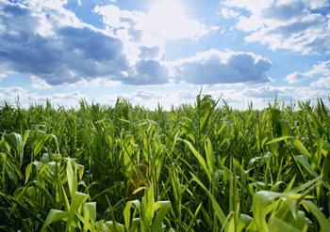
I’ve always had a sentimental attachment to cornfields—from the magical cornfield in Field of Dreams to the real cornfield across the road from a house I lived in during college years. My mother was born and raised in Iowa and I’m descended from farmers.
But chemicals, in particular Atrazine, used as herbicides on cornfields might be poisoning frogs (and people), and turning fields of dreams into fields of nightmares. These herbicides run off cornfields into streams and rivers, and leak through the water-treatment process, contaminating groundwater and drinking-water supplies.
Last summer we blogged about the problems of Atrazine. Research by University of California, Berkeley professor Dr. Tyrone Hayes, for example, has shown the effects this chemical—an endocrine disruptor—has on frogs. It can cause birth defects and reproductive problems, including such bizarre deformities as male frogs with eggs in their testes. This past week, as reported in the Washington Post, new research at the University of Ottawa found that when exposed to Atrazine fewer tadpoles reached froglet stage. Atrazine appears to affect estrogen in humans as well and has been connected with fertility problems, cancer, and birth defects.
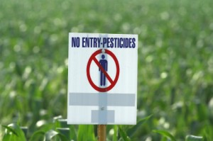
Warning in a Cornfield
The EPA, under the Obama administration, has launched a review of the chemical that will continue until fall 2010. It will look closely at Atrazine and other endocrine disruptors, which might result in tighter restrictions on their use. While this sounds hopeful, Atrazine’s primary manufacturer, Syngenta, has strong ties and influence within the EPA. (Atrazine is banned in Europe, where perhaps industry and government aren’t as closely intertwined as they are in the U.S.).

Frog Scientist: Dr. Tyrone Hayes and Atrazine
Posted on July 16, 2009 by Susan
In my post Rachel Carson’s Legacy, I wrote about widely-used chemicals called endocrine disruptors that are causing deformities in fish and frogs, and are linked to an increase in genital deformities in newborn baby boys.
When reading about endocrine disruptors, I keep coming across the work of Dr. Tyrone Hayes, a professor in the Department of Integrative Biology, at the University of California–Berkeley. He has studied the effects on frogs of an agricultural pesticide called Atrazine. Hayes found that these chemicals, even at very low levels, were causing male frogs in the wild to develop eggs in their testes (!).
I came across a lecture Dr. Hayes gave called “From ‘Silent Spring’ to Silent Night.” The lecture is about an hour long, but it’s worth watching (see below). Hayes is a funny and engaging speaker and he uses easily understood charts/graphs/pictures to explain how these chemicals effect the frogs—and how they might also affect you.
One Dr. Hayes’s experiments with frogs really hit home with me. He studied two groups of frogs that live along the same river in California. For the experiment he placed the frogs, same species, in cages in the water. One group was placed upstream of the Salinas valley, one of the largest agricultural areas of the country, which is farmed intensely all year round. Runoff containing Atrazine and other chemicals from the farms flows into the river.
The other group of frogs was placed about 50 miles downstream in a clean area. He found that the tadpoles in the area near the farms had retarded growth. They were tiny compared to the frogs in the healthier area. Hayes then injected both groups of frogs with bread yeast. The group of frogs near the farms died within a day or two after being injected with the yeast. The other frogs, from the cleaner area upstream of the agricultural area, survived. They were larger and had stronger immune systems and so were able to fight off the effects of the yeast.
I am not a scientist, but it does make me wonder about claims that some scientists make that the various viruses, parasites, and even the recent claim that frog deformities are caused by dragonfly larvae, are “part of nature.” The frogs living in the “chemical soup” obviously were smaller, weaker, and more susceptible to parasites and diseases.
As Hayes says, we can’t just pass this off as a frog problem that isn’t relevant to humans. Our hormones are chemically identical to frog hormones. Hayes discusses studies indicating higher breast cancer rates in areas where Atrazine is in the well water. He points out that the effects of the chemical may not be obvious now, but may be carried to our children, grandchildren, and even great-grandchildren.
How can you reduce your own exposure to Atrazine? If you live in the Midwest or other agricultural areas, you might consider drinking bottled water or use a Brita filter on tap water, particularly if you are pregnant. The runoff from farms is at its worst from May to August (in the Midwest). As Elizabeth Royte writes in her book Bottlemania: How Water Went on Sale and How We Buy It:
Human kidneys filter Atrazine, and most people don’t spend a lot of time swimming in herbicide-laced water as frogs do. But human fetuses do.
I was surprised to learn that Atrazine is sprayed on Christmas trees as well.
I Know… I Wonder…
Research T-Chart
What I Know | What I Wonder
What do I want to find out about my topic?

